Geo-Search Concept
With existing Schools

Stored Procedure pss_GeoInformationFirst

TIS02O
Read entries where Kz_Serienbrief = 1

Call

Stored Procedure pss_GEOI_IUD

Google Web Service is not available
IF
Call
Inserts data
Stored Procedure
pss_GetLongLat
Google Web Service
Sends request
Returns response

Google Web Service is available

IO_GEOPOSTAL Table
Data

IO_GEOINFORMATION Table

On registration or update of a school.
Java Interface

Web service
Sends data
thillmuser.psp_ANSC_IUD
thillmuser.psp_Add_ANSC_i
TIS02O

@ANSC_ID
Stored Procedure
pss_GetLongLat

Google Web Service is not available
Google Web Service is available

IF
Call
Stored Procedure
pss_GetLongLat
Stored Procedure pss_GEOI_IUD

SQL Agent
Executes the stored procedure in a determinated period of time
Stored Procedure
Pss_TemporalGeoIn
IO_GEOINFORMATION Table
IO_GEOPOSTAL Table
Data
Call
Inserts data
@ANSC_KZ_SERIENBRIEF = true

IF

Google Web Service
Sends request
Returns response

Reads entries where ISTEMPORARY = 1

Call

When the user wants to find the schools.
Java Interface

Web service
Sends request
iBATIS
Sends data to the interface to be able to show the map
Stored procedure
tspadm.psp_GetSchule in TIS02O

Stored procedure
tspadm.psp_GetSchule in TSP02O

Returns data
Sends @USER_LONGITUDE, @USER_LATITUDE, @RADIUS, @NUMBER_OF_NEAREST

Stored procedure
pss_GetUserGeoInformation
Sends Postal Code, City and street
@POSTAL_CODE is not null
Returns User Longitude and Latitude
IF
Call
Call
Returns data

Sends parameters
@USER_LONGITUDE AND @USER_LATITUDE are not null
Stored procedure
pss_GetGeoSearchSubSelect
IF
Returns @SQL
Stored Procedure
pss_GetLongLat

IF
Call
Stored Procedure
pss_GetLongLat
Google Web Service
Sends request
Returns response

Google Web Service is not available
Google Web Service is available

IO_GEOPOSTAL Table
User GeoData

IO_GEOINFORMATION Table
Schools GeoData
Schools GeoData

Geo-Search Database Model

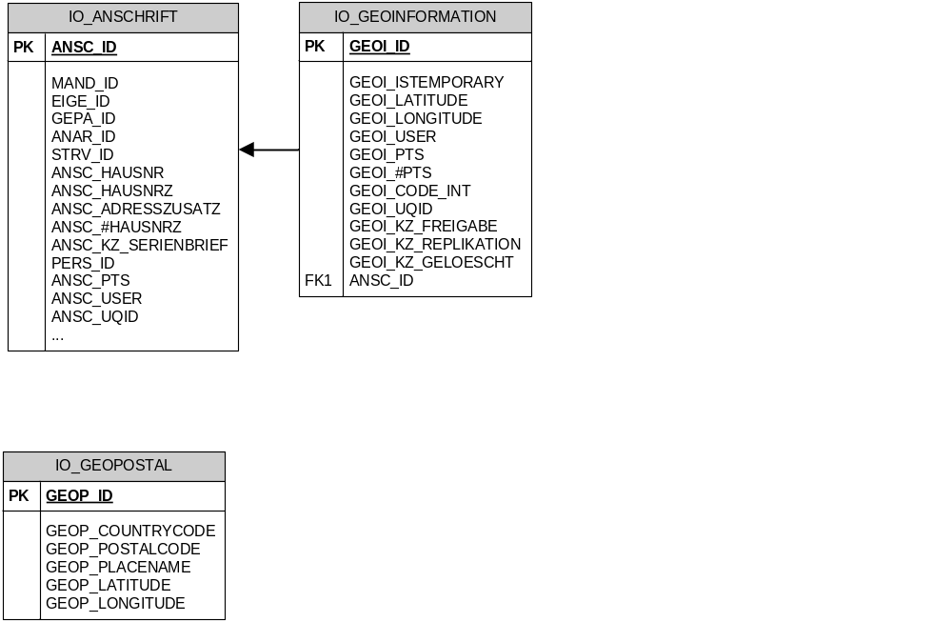

The steps used to import PostalCodes into SQL 2005:
- Download DE.zip from http://download.geonames.org/export/dump/
- Convert the file to UTF-16, we used the the following code with C#:

Code:
using System;
using System.Collections.Generic;
using System.Linq;
using System.Text;
using System.IO;

namespace Utf8ToUtf16
{
class Program
{
static void Main(string[] args)
{
Int64 rowsBeforeStatus = long.MaxValue;
if (args.Length > 2)
{
rowsBeforeStatus = Convert.ToInt64(args[2]);
}

using (FileStream inputFile = File.Open(“C:/DE.txt”, FileMode.Open, FileAccess.Read, FileShare.Write))
{
using (StreamReader inputStream = new StreamReader(inputFile, Encoding.UTF8))
{
using (FileStream outputFile = File.Open(“C:/DE16.txt”,FileMode.Create, FileAccess.Write, FileShare.Write))
{
using (StreamWriter outputStream = new StreamWriter(outputFile, Encoding.Unicode))
{
if (rowsBeforeStatus == long.MaxValue)
{
while (!inputStream.EndOfStream)
{
outputStream.WriteLine(inputStream.ReadLine());
}
}
else
{
Int64 totalLinesProcessed = 0;
while (!inputStream.EndOfStream)
{
Int64 i = 0;
while (i < rowsBeforeStatus && !inputStream.EndOfStream)
{
outputStream.WriteLine(inputStream.ReadLine());
i++;
}
totalLinesProcessed += i;
Console.WriteLine(totalLinesProcessed + " lines processed");
}
}
}
}
}
}
}
}
}

- Create the table:

CREATE TABLE [geoiadm].[IO_GEOPOSTAL](
GEOP_COUNTRYCODE VARCHAR(2) NOT NULL,
GEOP_POSTALCODE VARCHAR(10) NOT NULL,
GEOP_PLACENAME NVARCHAR(200) NOT NULL,
GEOP_ADMINNAME1 NVARCHAR(100) NULL,
GEOP_ADMINCODE1 VARCHAR(20) NULL,
GEOP_ADMINNAME2 NVARCHAR(100) NULL,
GEOP_ADMINCODE2 VARCHAR(20) NULL,
GEOP_ADMINNAME3 NVARCHAR(100) NULL,
GEOP_LATITUDE FLOAT NOT NULL,
GEOP_LONGITUDE FLOAT NOT NULL,
GEOP_ACCURACY SMALLINT NULL, )

*Note: columns sAdminName1, sAdminCode1, sAdminName2, sAdminCode2, sAdminName3, sAdminCode3 and iAccuracy are useless.

- Using "SQL Server Import and Export Wizard" do the following.
- Specify Flat File Source.
- Choose the source file. i.e. DE16.txt (You should see that Unicode is automatically checked, if the UTF8 to UTF 16 conversion was successful).
- In the Columns section can the Column Delimiter to Tab and click Refresh (You should see that all the columns look correct without any strange 'tab' characters).
- In the Advanced section (the most important) you need to specify the specifications for each field. Use Suggest Types... option and change the number of rows to 1000 and click OK. (this is an optional step but it'll save some time)
- Next use the table specifications to define each column. For any integer field, I specified "eight-byte signed integer" . Also "Column 10" and the 11th field in GeoNames you need to specify Unicode String and length 20 as per the specifications, since "Suggest Types" defines it as a single-byte integer.
- Once you have done all this, you can specify the destination, make sure you specify the destination table as the one you created since it will default to a new table using the file name.
- Hopefully, the data import will finish successfully. Otherwise you may have to adjust you source column specifications (We missed some fields the first time I did this).

*Note: After doing this you can add GEOP_ID column.

